Creating a WBS and Network Diagram
Figure 1: WBS for the Upgraded Network Software
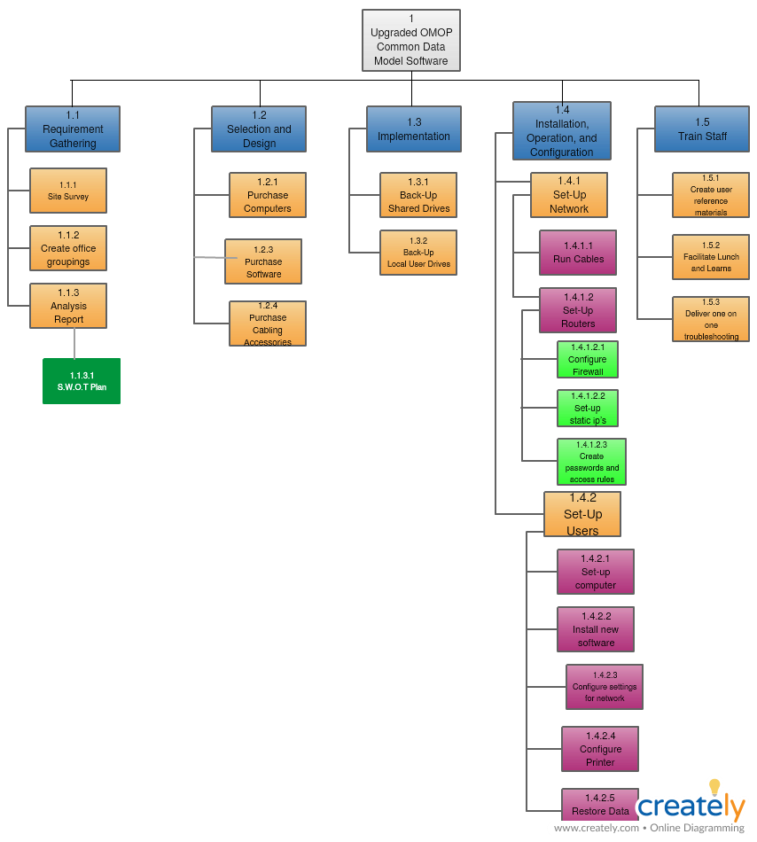
Figure 2: Network Diagram for Upgraded Network Software
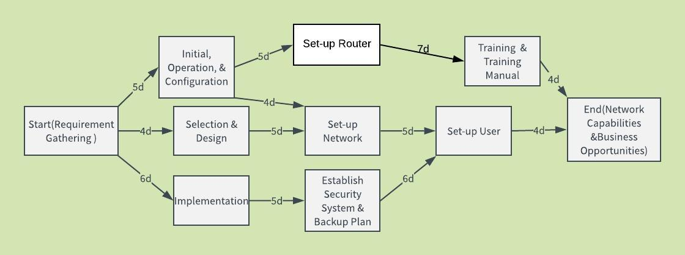
Figure 1 above depicts the Work Breakdown Structure (WBS) for an Information System project. A project manager utilizes several management tools that include WBS, which aims to improve consistency in execution and planning of the activities (Loudon & Loudon, 2014). A WBS tool facilitates a project manager to breakdown the complex activities inherent in a project into measurable and independent scopes (Markgraf, 2019). Consequently, figure 1 exhibits the measurable tasks involved in upgrading and installing network software.
Notably, a project to upgrade existing network software merits because it improves the capabilities and bolsters the calibers of business opportunities (Markgraf, 2019). The project has five distinctive and measurable deliverables that enhance the achievement of the two objectives of software upgrade and installation. First, the Requirement Gathering deliverable is core pre-installation task because it ascertains the suitable path to undertake during the network upgrade. The deliverable aims to develop a robust Analysis Report that concerns to the current status quo of the network requirement. A site survey and interviewing the internal users are the profound activities inherent in the Requirement Gathering stage. Importantly, the availability of adequate information from the diverse users yields S.W.O.T Report, which exemplifies the strengths, weaknesses, opportunities, and Threats respectively.
Secondly, the analysis report influences the Selection and Design deliverable, which facilitates the acquisition of the software as well as the hardware components. A site survey outlines the inadequacies in the current network system that includes inferior internet connectivity, limited user capacity, and security loopholes, which necessitates the selection of superior computer hardware. Moreover, the new software designs hinge on the compatibility with modern competencies to improve on the users’ experiences. The acquired computer accessories demonstrate rigorous tradeoffs that involve the performance and cost considerations, which represent the critical activity in the Selection and Design phase.
Third, the Implementation Stage is relatively a straightforward process depending on the lack of significant incidences in the first two phases. An implementation schedule that focuses on establishing new security standards and backup capabilities demonstrates a pertinent activity that characterizes the third deliverable. An effective implementation schedule aims to mitigate disruption of the customer service delivery after the installation of the new system network (Loudon & Loudon, 2014). Consequently, the provision of backup capabilities in the new network system enhances the proactive management of risks because it outlines the possible course of actions to alleviate unforeseen events.
Fourth, Installation, Operation, and Configuration stage represent the strategic deliverable in the project because it influences the cadres of set-ups necessary to boost the network capacity and business opportunities using an upgraded system. The stage entails two scopes that include setting the network modules and aligning the users’ setting. Therefore, the teams delegated to undertake the Installation, Operation, and Configuration activities are tasked to develop a robust firewall as well as the password models. The stage also constitutes the longest deliverable because it entails 11 days to actualize the desired deliverables.
Lastly, the Training Deliverable represent another source of competitiveness in a network system because it eliminates the threat of resistance, facilitates cost saving, and boost the support mechanisms. A revised training curriculum demonstrates an integral outcome in the stage because it aims to introduce users to the new security features and operation. Moreover, adequate training improves the level of preparedness among the users, which is an essential input to achieve positive outcomes after installation.
Concisely, a strategic project manager in the ICT sector hinges on the profound management tools that include a WBS to enhance efficiency and consistent planning. Profoundly, the reliance of a WBS tool is a strategic intervention during installation of a software upgrade because it enhances the critical success area in an IT project. The ability to document the real-time customer reactions, bolster productivity, and achieve cost-effectiveness using an upgraded network system depicts the critical success area in the project, which triggers the use of effective project management tools to yield desirable outcomes.

References
Loudon, K. & Loudon, J. (2014). Management information systems: Managing the digital firm, (13th Edition), Boston, MA: Pearson Education
Markgraf, B. (January 28, 2019). “The importance of a work breakdown structure,” The Chron. Retrieved from www.smallbusiness.chron.com/importance-work-breakdown-structure-54294.html [Accessed March 6, 2019]

